Power BI Assignment 1 – Data Transformation & Data Modelling
Data Transformation:
Restrict the "List of Orders" table to only the first 500 rows.
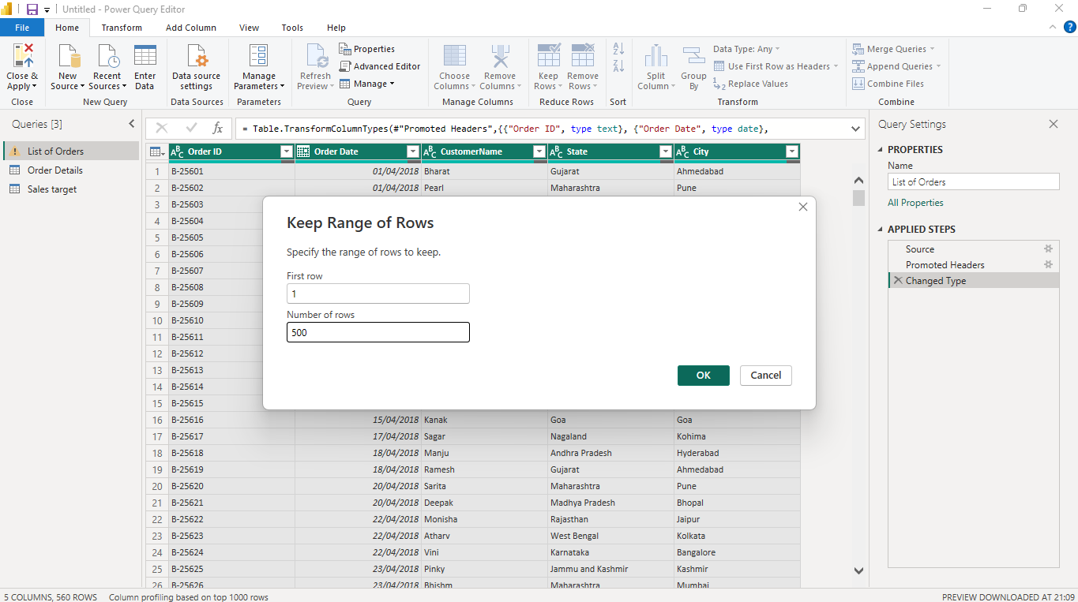
Change the data type of “Amount” and “Target” columns to ‘Fixed Decimal Number’.
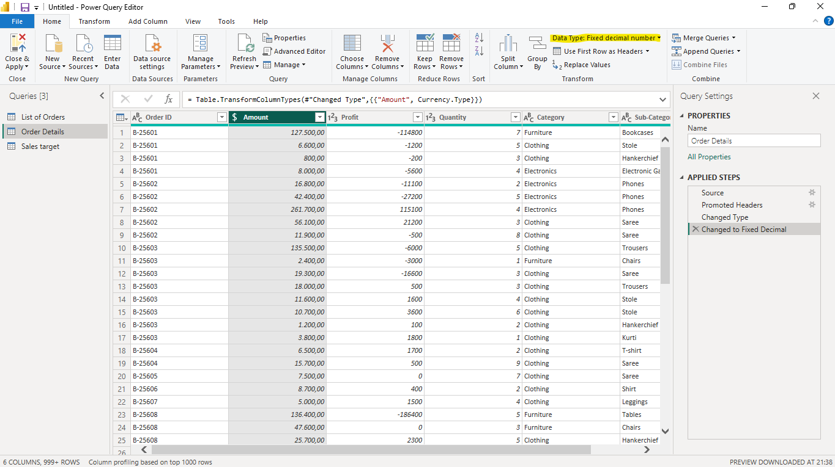
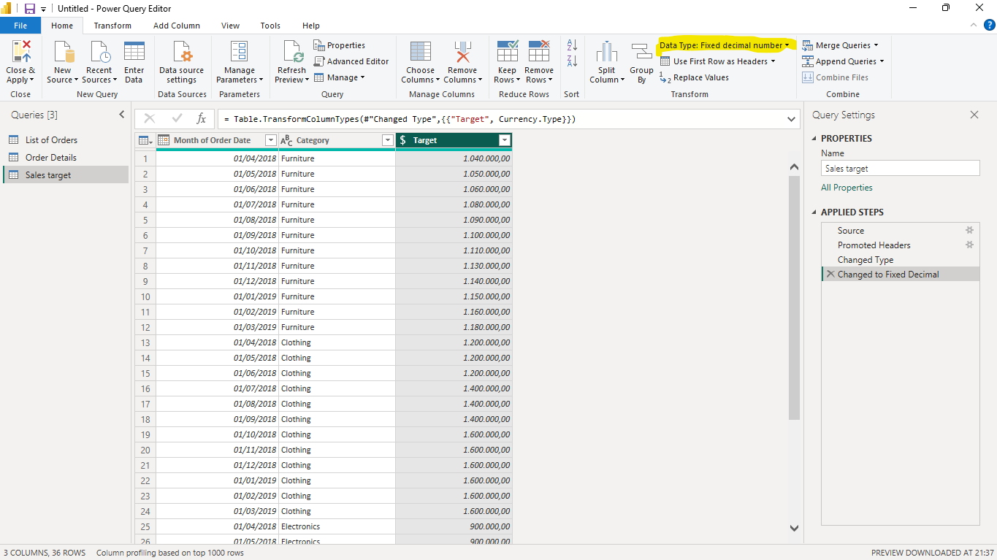
Format the "Customer Name" column into proper case, ensuring consistent
capitalization for each word.
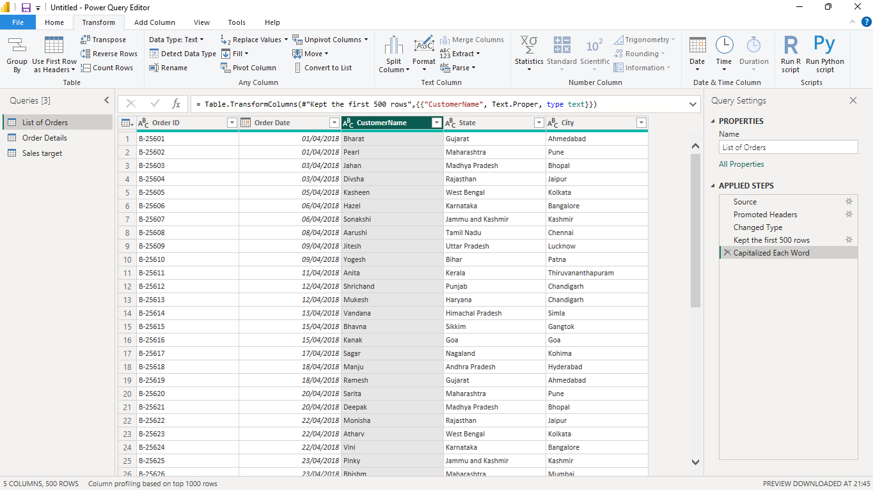

Merge the "State" and "City" columns to create a new column named "Location" in
the format ‘City, State’.
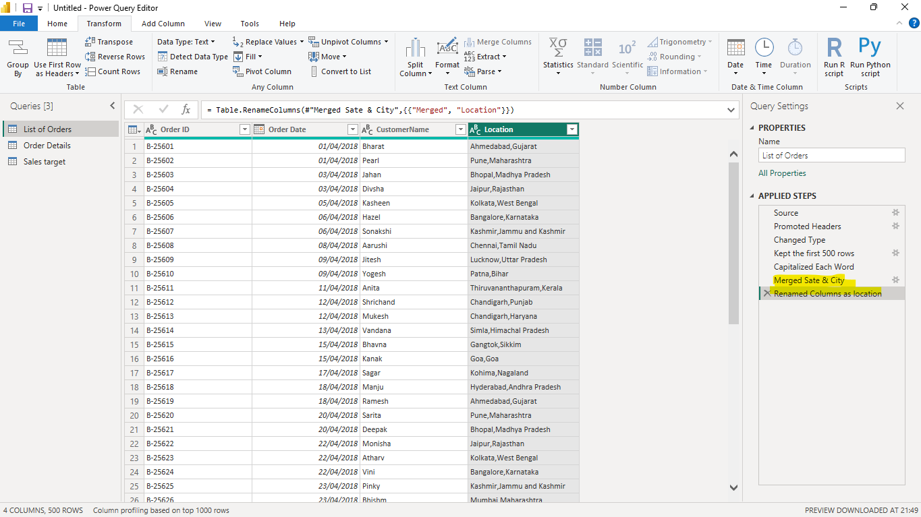
Create a new custom column named "Profit Margin" as the percentage of "Profit"
divided by "Amount".
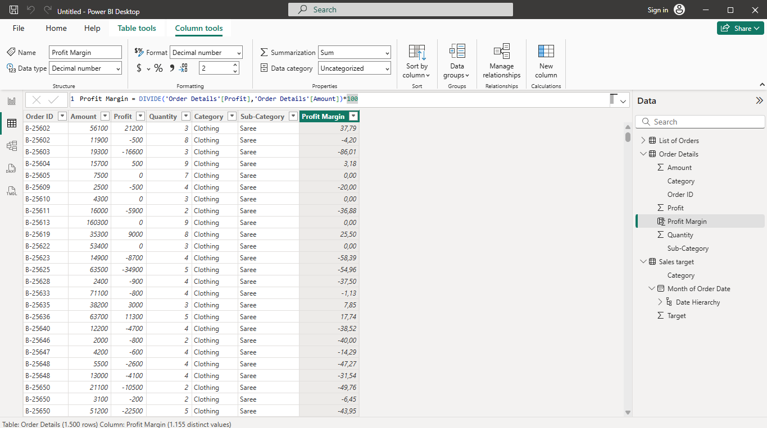

Add a new conditional column named "Profit Status" based on the values in the
"Profit" column. The conditions are as follows: if the profit is less than 0, the label
should be "Loss"; if the profit equals 0, the label should be "Break-Even"; and if the
profit is greater than 0, the label should be "Profit".
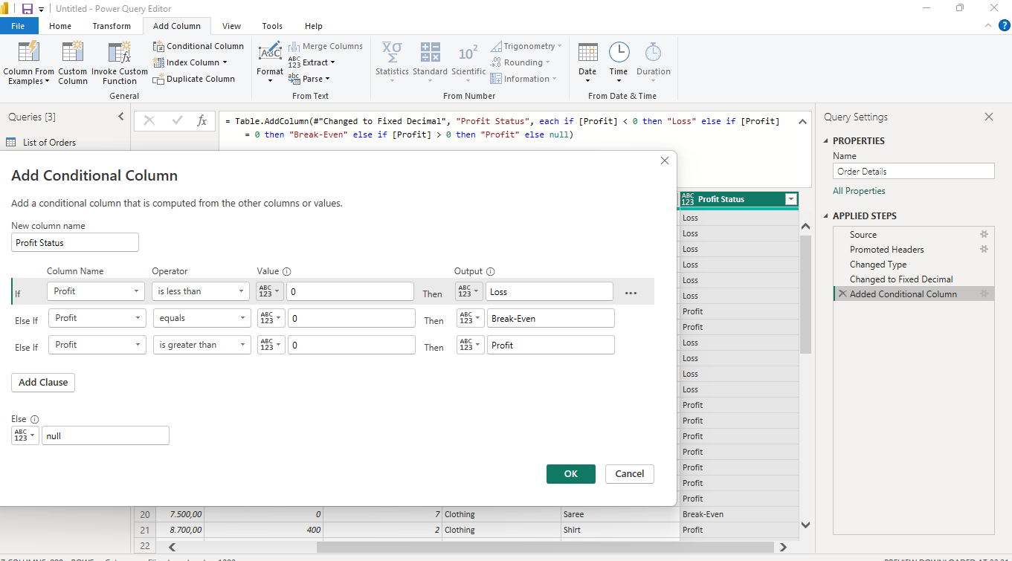
Merging Data (Joins):
Merge the "List of Orders" and "Order Details" tables into a new single table named
"Orders Data" based on the "Order ID" relationship.
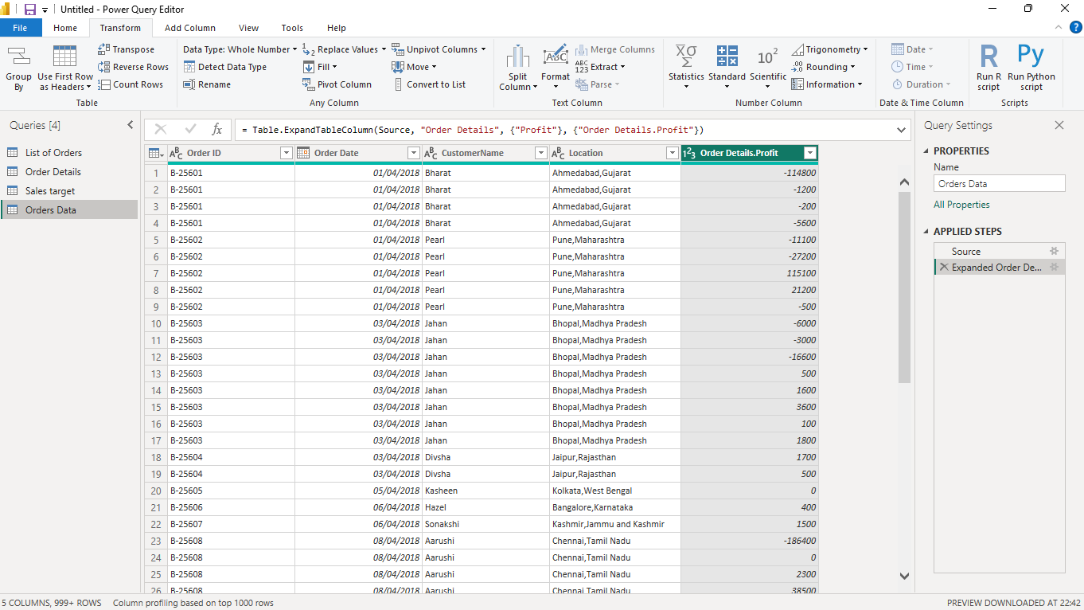
Sorting and Filtering Data:
Sort the orders by Order Date in descending order to analyze recent trends.
Filter the orders to focus only on a specific state (e.g., Tamil Nadu) for
regional analysis.
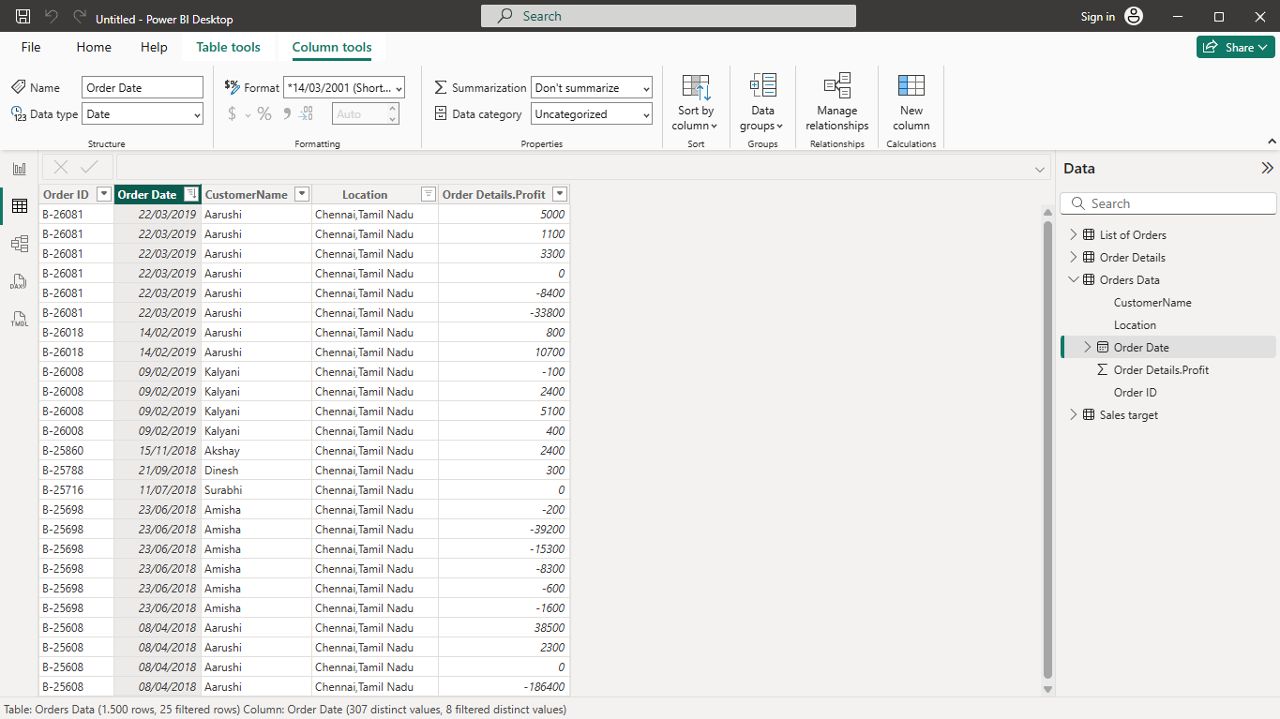
Grouping and Aggregating Data:
Duplicate the “Order Details” table and calculate the count of each Order ID, average
profit by Category or total amount by Sub-Category.
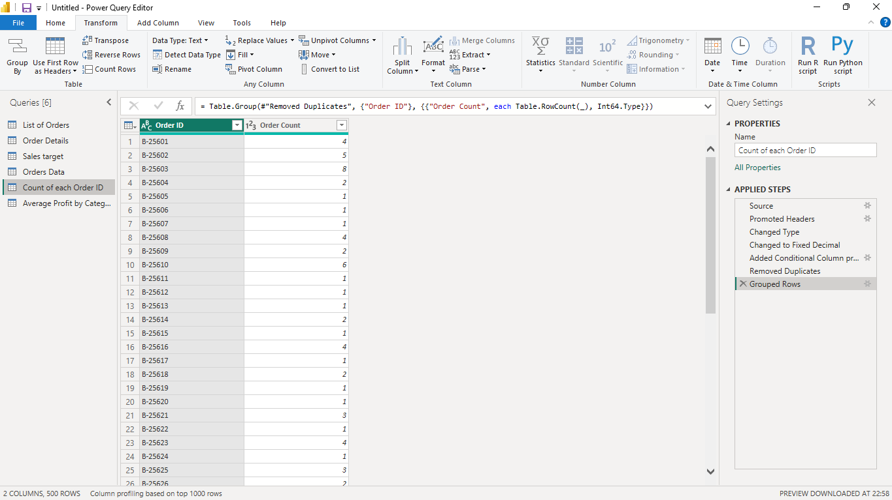
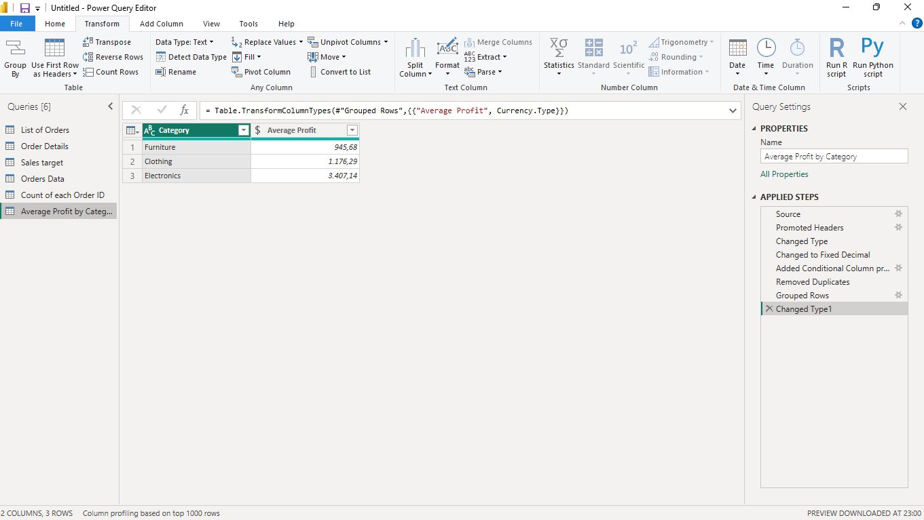
Duplicate the “Sales Target” table and aggregate the total target amount by Month of
Order Date.
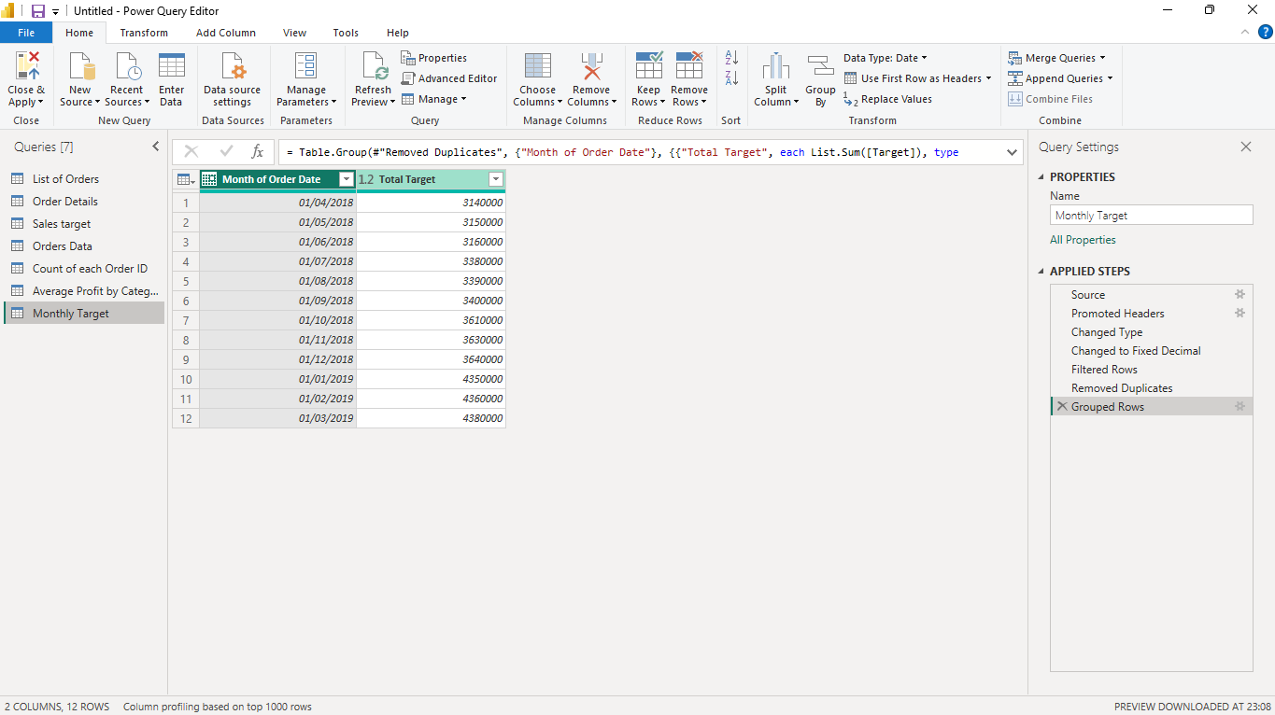

Data Modelling+:
Establish a relationship between the “List of Orders” and “Order Details” tables using
the ‘Order ID’ column
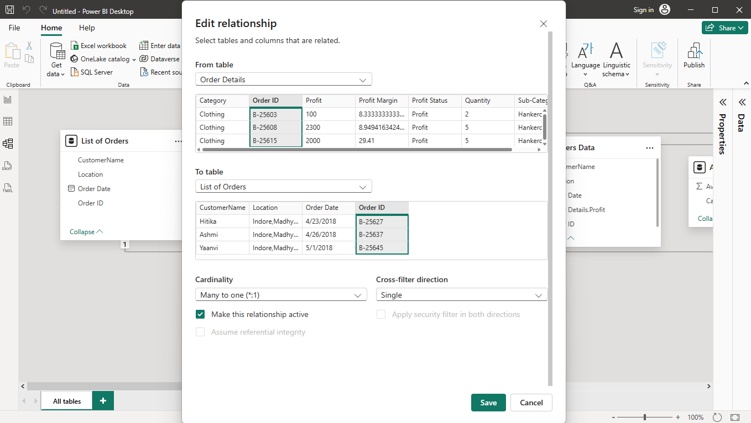
Build a relationship between the “Order Details” and “Sales Target” tables based on
the ‘Category’ column. Click "Manage relationships" and ensure this relationship is
active.
